1)What is a Network?

A network consists of two or more computers that are linked in order to share resources (such as printers and CDs), exchange files, or allow electronic communications. The computers on a network may be linked through cables, telephone lines, radio waves, satellites, or infrared light beams.

Two very common types of networks include:

Local Area Network (LAN)

Wide Area Network (WAN)

2)IP address definition?

An IP address is a unique address that identifies a device on the internet or a local network. IP stands for "Internet Protocol," which is the set of rules governing the format of data sent via the internet or local network.

3)what is internet?

The Internet is a vast network that connects computers all over the world. Through the Internet, people can share information and communicate from anywhere with an Internet connection.

4)what are networking commands?

BASIC NETWORKING COMMANDS:

1)hostname- we get to know hostname

hostname -d :displays name

hostname -f :fully qualified host and domain name

hostname -i :displays ip address of current

2)netstat-used for socket programming we can see routing table

netstat -a :all information including TCP and UDP

netstat -t:see tcp connection

netstat -u:see udp connection

netstat -l:list only listening ports

netstat -b: we can see active applications

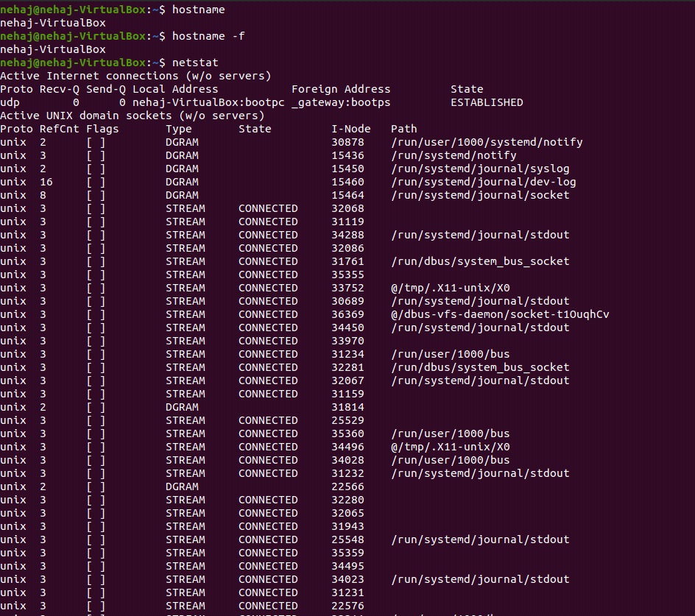

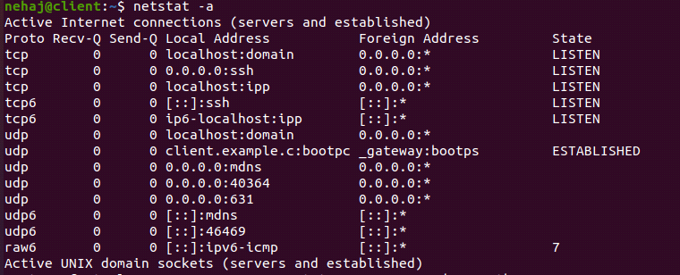

3)ping-ping is used to test network connection(packet internet grouper)

ping ipaddress

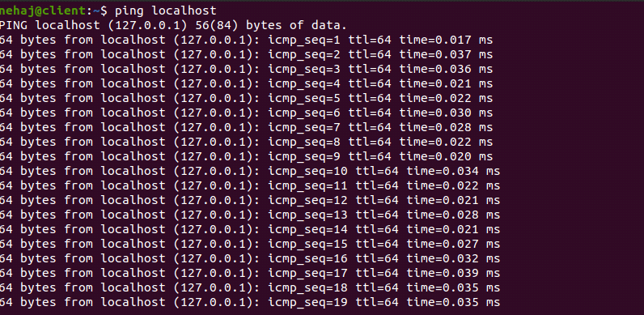

4)ifconfig-we get network configuration

ifconfig -a:we can see all network configuration and setting

ifconfig etho:we can get particularinformation

ifconfig etho down:disabling etho

ifconfig etho up:enabling etho

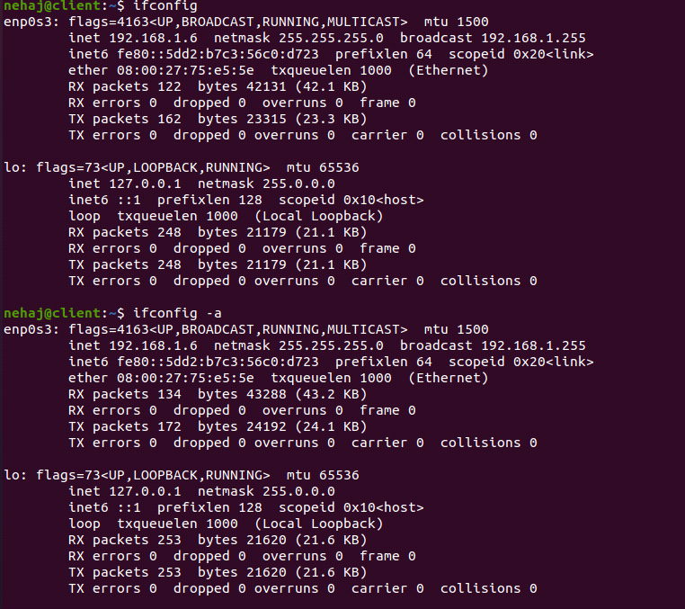

5)traceroute-it traces route of two systems how packets transfer from source to destination

tracert Destination Name or IP address

tracert <www.google.co.in>

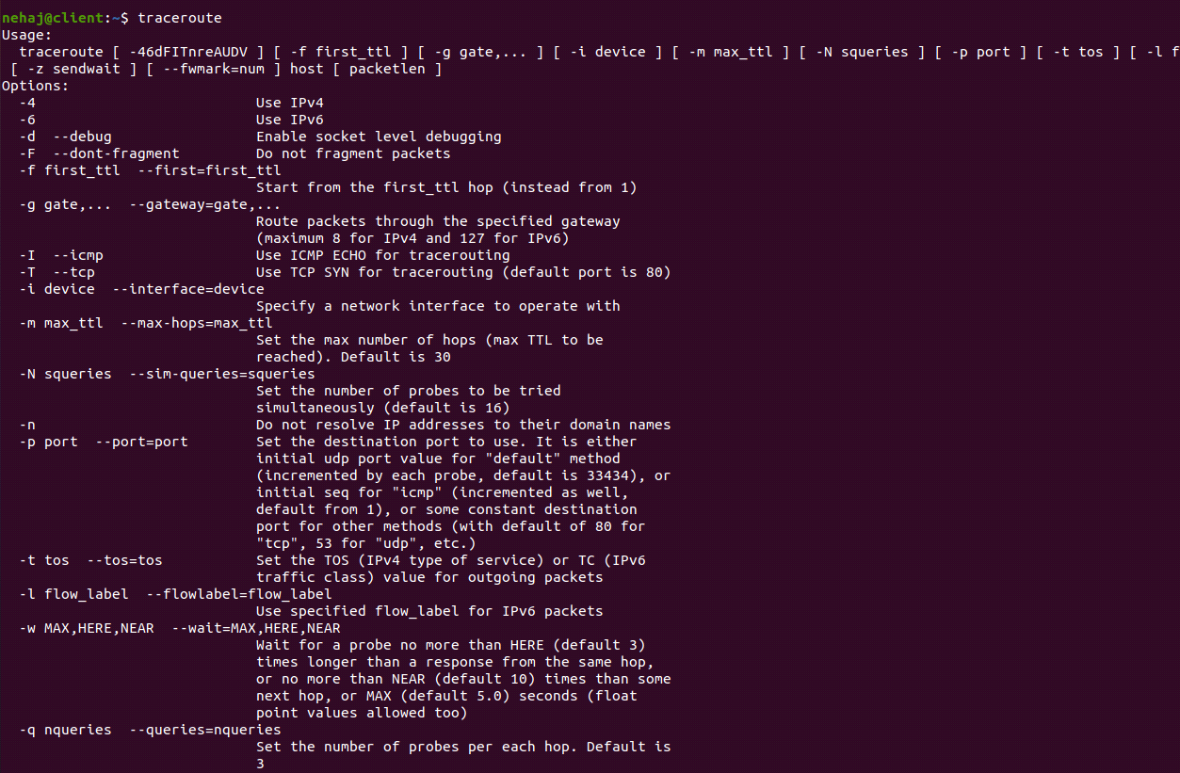

6)nslookup-in this we know host name and get ip address or

we know ip address and get host name

